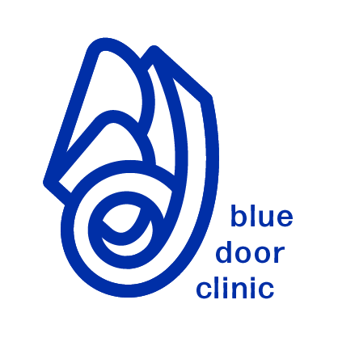**Blue Door Clinic**

Located at *Regent Park Community Health Centre*

465 Dundas Street East, 2nd Floor, Toronto, Ontario M5A 2B2

Phone: 437-235-7423

Fax: 416-364-0822

www.bluedoorclinic.org

Blue Door Clinic provides healthcare to people living with HIV in the Greater Toronto Area who are non-insured/under-insured. This includes (but is not limited to) temporary immigration statuses such as: migrant workers and those awaiting renewed contracts or work visas, newcomers awaiting inland processing and review of their immigration and refugee applications, individuals with active visitors visas who are not eligible for care through a community health centre, Canadian-born individuals who do not have adequate identification due a variety of adverse life circumstances, international students whose mandatory health insurance does not cover the full range of HIV care etc.

All services are free and confidential and include: HIV primary care/ health assessments provided by a doctor/ nurse practitioner, treatment for HIV and other health conditions, laboratory testing, immunizations, connection to medication access programs, referral to specialists (if needed), referral to community supports (e.g. housing, legal, settlement etc.), referral to ongoing healthcare when eligible.

**Patient Information:**  *\*To assist the intake process, please provide any many details as possible*

First Name: Last Name:

Date of Birth: Gender: Phone Number:

Address: Email:

Immigration Status: Date Arrived in Canada:

Languages Spoken: Interpretation Required:  Yes /  No

Year of HIV diagnosis: Country of HIV diagnosis:

Is this person currently taking medication for the treatment of HIV?  Yes /  No

Name(s) of HIV Medication: # of doses remaining:

**Referral Information:**  Community Agency  Healthcare Provider  Self-Referral

Date of Referral: Agency:

Contact Person: Email:

Telephone: Fax:

**Additional Information:**